Task 1 – Customer Behavior Analysis
Objective
The objective of this project is to analyze customer transactions and behavior to identify customer segments, purchasing patterns, and potential churn risks for Alfido Tech.
Data Preparation
The dataset was cleaned by checking missing values, duplicate records, and data types. Relevant transaction and customer features were prepared for further analysis and segmentation.
Customer Segmentation
Customers were segmented using RFM analysis based on:
- Recency – How recently a customer purchased
- Frequency – How often a customer purchased
- Monetary – How much a customer spent
The resulting segments were profiled to understand differences in customer value and engagement.
Key Analysis
The project includes:
- Customer segment distribution
- Purchase frequency and spending patterns
- Revenue/purchase trends
- Product category preferences
- Customer retention and churn-risk indicators
- Segment-wise customer behavior
Key Findings
The analysis identifies high-value customers, regular customers, occasional customers, and customers showing potential disengagement. These insights can help Alfido Tech personalize marketing and improve customer retention.
5 Recommendations
- Provide loyalty rewards to high-value customers.
- Use personalized offers to increase repeat purchases.
- Target inactive customers with reactivation campaigns.
- Promote relevant products based on customer purchase patterns.
- Monitor customers with declining purchase frequency and take early retention actions.
Deliverables
Notebook / Code: https://www.kaggle.com/code/chanchalkarnawat/task1
Screenshots & Visualizations:
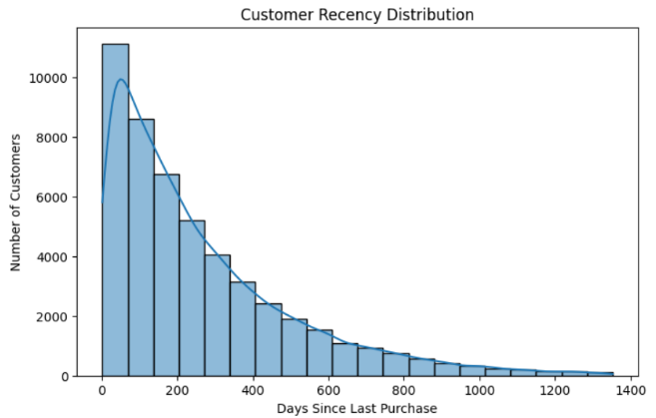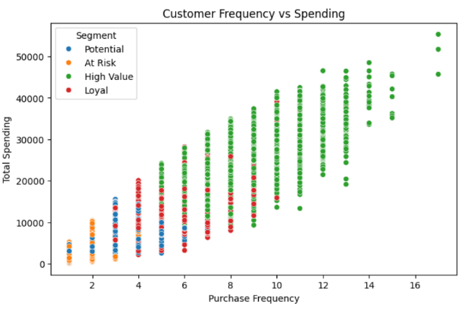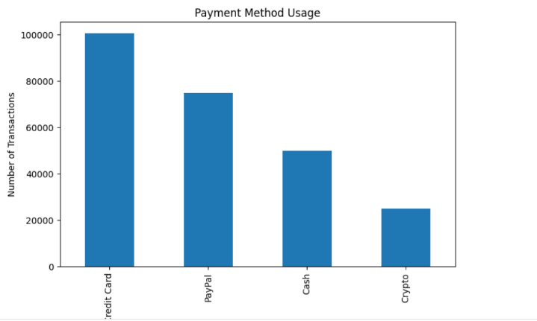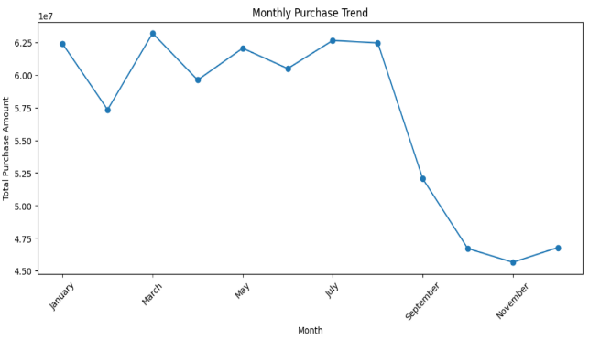
Conclusion
Customer segmentation provides a clear understanding of different customer behaviors and helps Alfido Tech make more targeted decisions for engagement, retention, and revenue growth.

